AAW

AWS ADVANCED ASSIGNMENT-6

DAY 13-14

ARAVIND G KUMAR

**Project : WORKING WITH RDS.**

Task 1: Create a security group.

* Go to EC2 from service tab.
* Under networking and security.
* Select security group.
* Create a security group.
* Give the SG a name.
* Edit the inbound rules
* Select SQL/AURORA and set the source as custom.
* Create the SG.

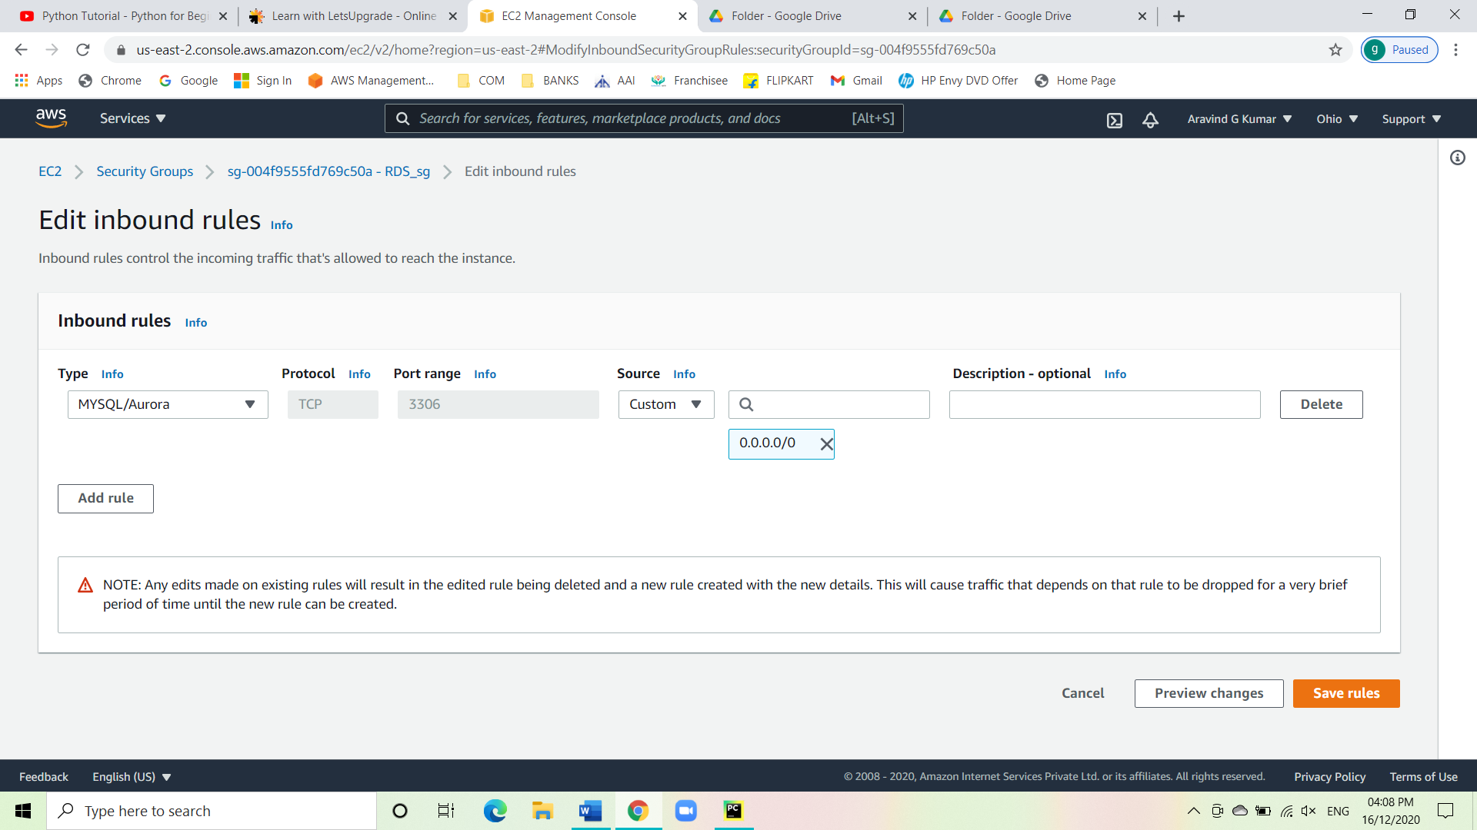

Task 2: Create Database.

* Go RDS from the service tab.
* Click on create database.
* Click on Switch to your original interface on top of your screen.
* Select the engine and on the bottom of the page check the box for free tier eligible.
* Specify the DB details.
* Set everything to default except for multi-AZ deployment and enable storage auto scaling.
* Set everything to default and create the database.

DB instance page:

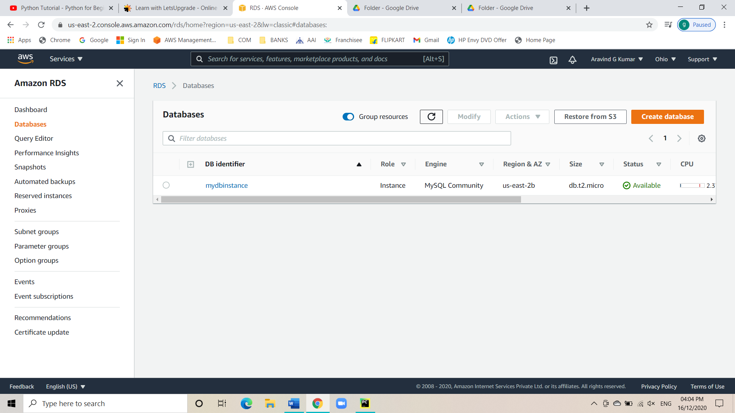

DB instance details:

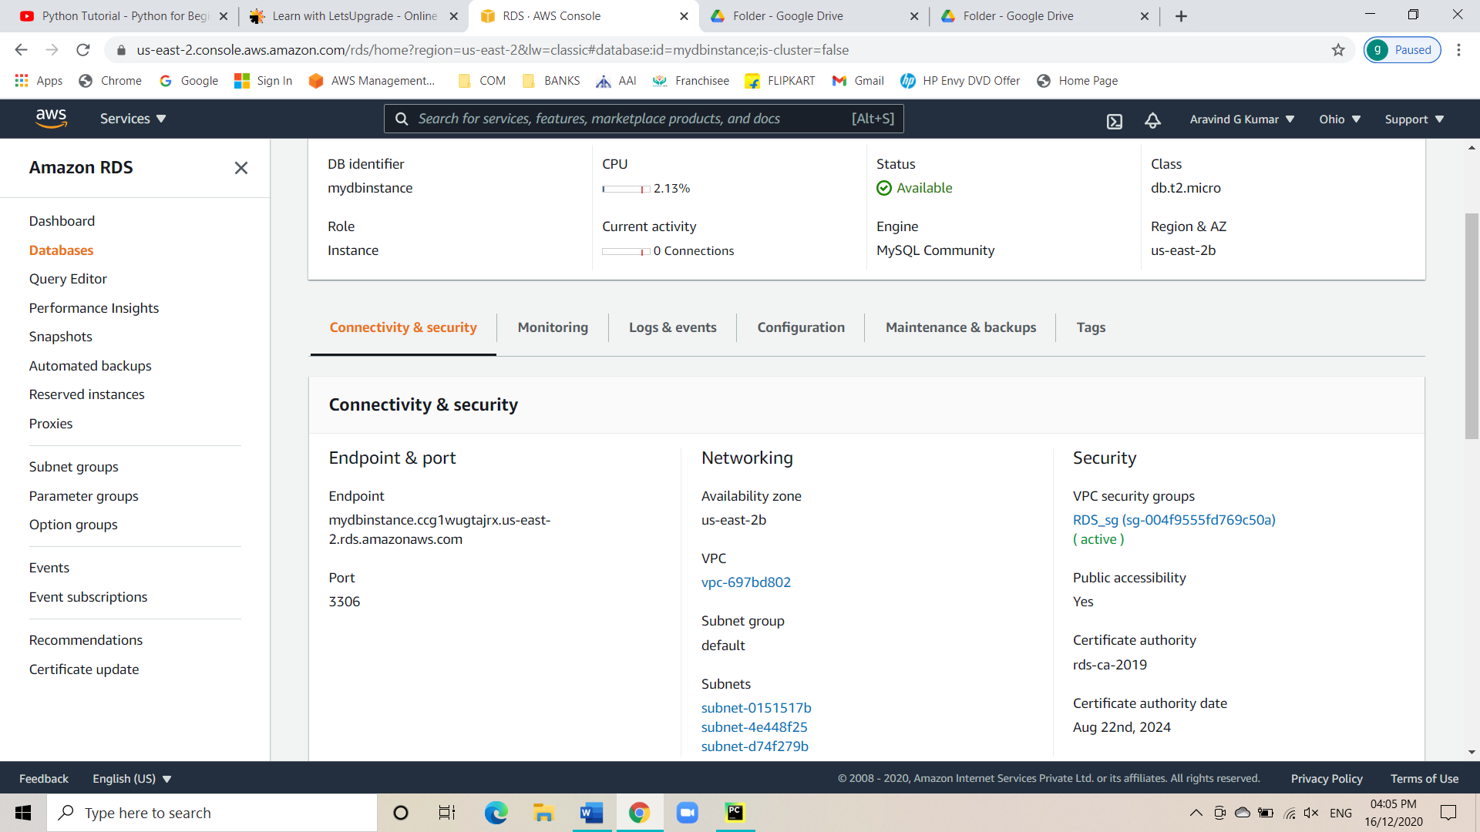

* Edit the inbound rule for SG.
* Change it from custom to anywhere.

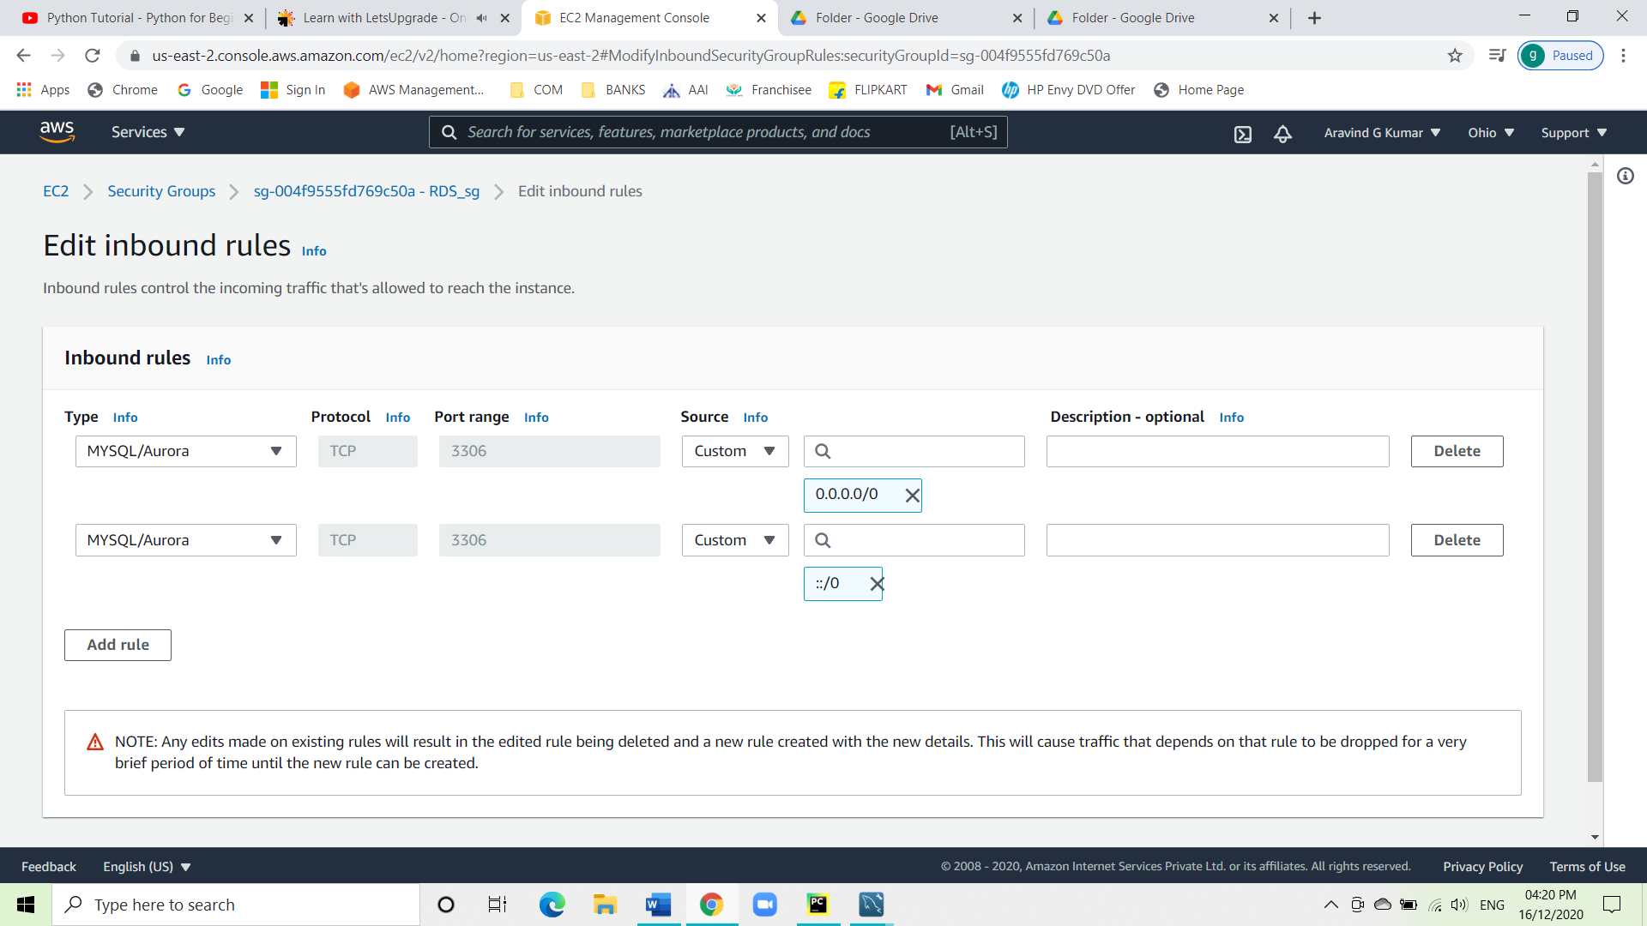

Task 2: Connect to MY SQL workbench.

* Under database click on connect to database.
* Under hostname paste the end point and set the port to 3306.
* Add the specified username.

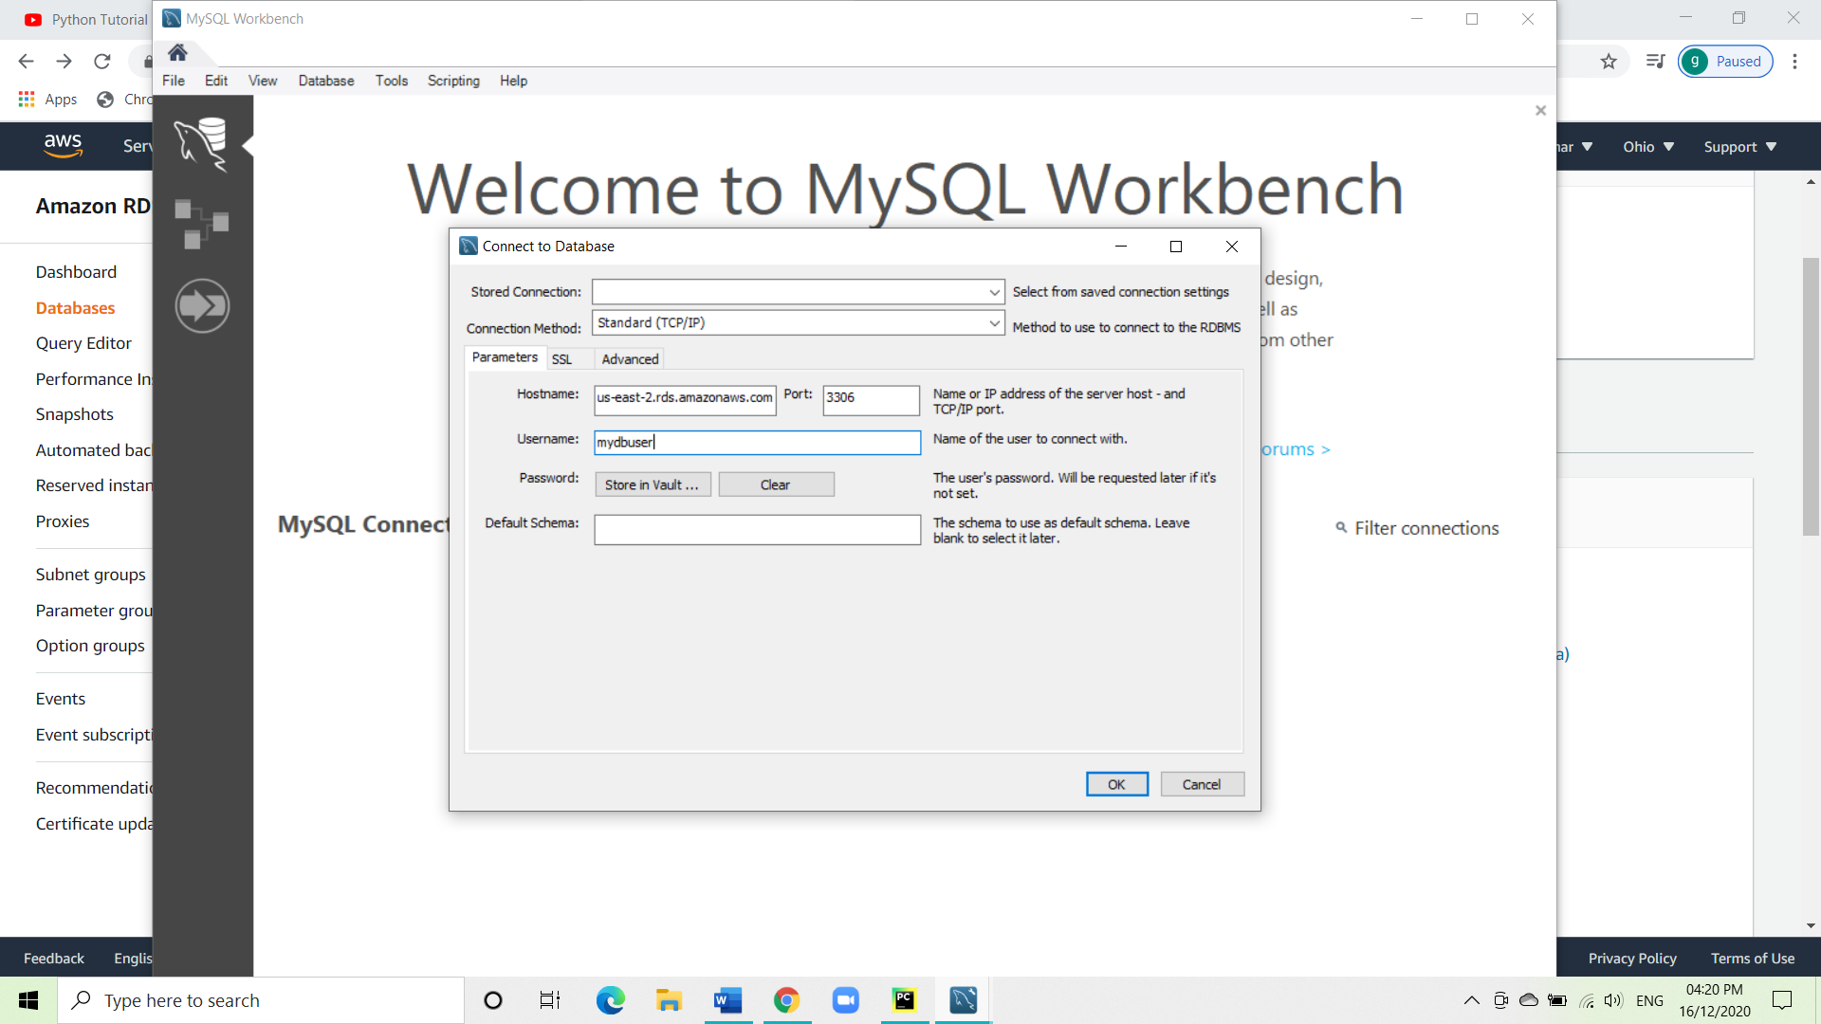

* Click on store in vault to give the password to gain access to the workbench.

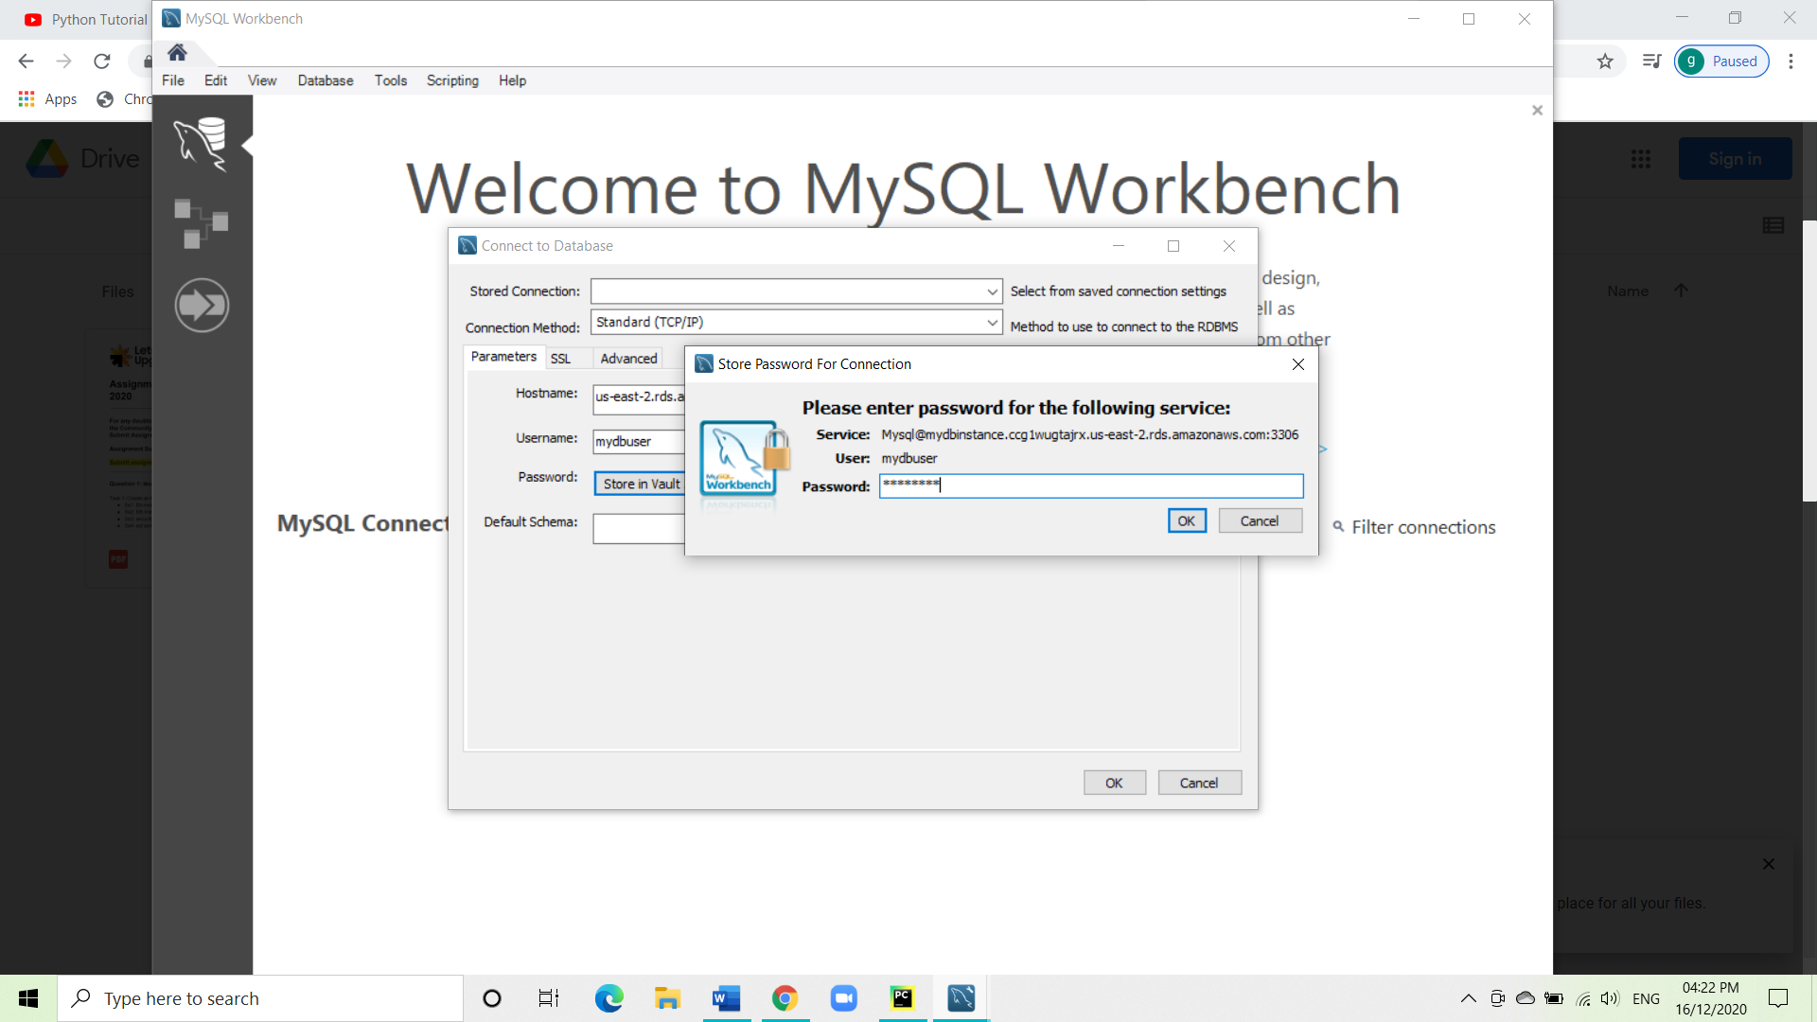

* Now the workbench is connected.

